**BSAI-3B  
Lab_Task_2  
Syed Tahir Ali 103  
Model Reflex Agent (Temperature Control System)**

**Overview:**

This is a **Model Reflex Agent** built in Python.  
It simulates a simple decision-making system where an agent monitors the **room temperature** and decides whether to **turn ON or turn OFF the AC** based on a fixed temperature threshold.

The program works as follows:

* If the **room temperature > fixed temperature** → AC is turned **ON**.
* If the **room temperature ≤ fixed temperature** → AC is turned **OFF**.
* If the required action is the same as the previous one → the agent displays **“No Change.”**

**1. Initialization**

* The agent is created with a **fixed temperature** value.
* A memory (last_action) is used to store the previous action for comparison.

**2. Sensor (Input from Environment)**

* The sensor() function reads the **room temperature**.
* The agent checks the environment (different rooms with different temperatures).

**3. Performance Function (Decision Making)**

* Compares **room temperature** with **fixed temperature**.
* Rules applied:
  + If room temperature > fixed temperature = **Turn ON AC**.
  + If room temperature ≤ fixed temperature = **Turn OFF AC**.
* If the same action is repeated → prints **“No Change.”**

**4. Actuator (Action Execution)**

* Displays the **room name, room temperature, and action taken**.
* For every room, the agent evaluates and acts accordingly.

**Example Run:**

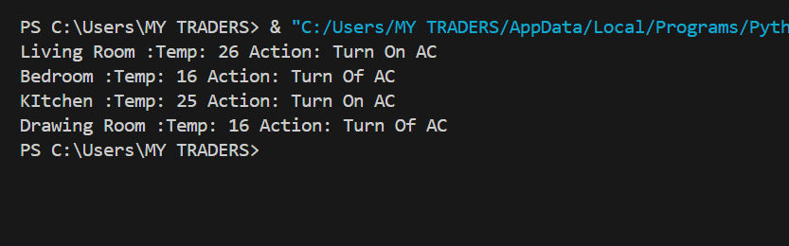

**Features:**

* Works as a **simple reflex agent** based on condition-action rules.
* Detects **room temperature dynamically** from the environment.
* Avoids **redundant actions** by checking the last action.
* Can be extended to handle **multiple devices or smart environments**.